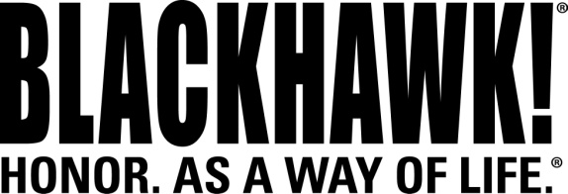

2014 NEW Products
Holsters

Standard Holsters for Glock 42 and M&P SHIELD
Are you looking for a rugged, stylish holster that fits your firearm like a glove? The BLACKHAWK!® Standard Holster features a pressure adjustable detent retention system that allows you to customize the amount of retention on the handgun. This innovative system grabs onto the pistol’s trigger guard and holds tight for a secure fit. New for this year, BLACKHAWK!® adds right- and left-handed holsters to fit the Glock 42 and Smith & Wesson M&P SHIELD.

Features & Benefits
- Comes complete with both a belt loop and paddle platform
- Available in Matte Finish
- U.S.A. made

Part No. Description UPC MSRP
415663BK-R S&W M&P SHIELD 9/.40 6 48018 21978 8 $21.99
415663BK-L S&W M&P SHIELD 9/.40 6 48018 21977 1 $21.99
415667BK-R Glock 42 6 48018 22009 8 $21.99
415667BK-L Glock 42 6 48018 22010 4 $21.99


